16010421091
Batch: D2 Roll No.: 16010221038

Name : Eshan Kalp Trivedi
Experiment / assignment / tutorial No. 3

Grade: AA / AB / BB / BC / CC / CD /DD

Signature of the Staff In-charge with date

TITLE: Menu driven program.

b. To calculate the sum of the Fibonacci series up to ‘n’ terms(use do-while loop only)
AIM: Write a menu driven program for following option
a. To find whether a number is palindrome or not. (e.g. 1221 is palindrome)
c. To find the numbers and sum of all integer between 100 and 200 which are divisible by both 3 & 5.(use for loop only)
______________________________________________________________________
Expected OUTCOME of Experiment:

_____________________________________________________________________
Books/ Journals/ Websites referred:

- Programming in C, second edition, Pradeep Dey and Manas Ghosh, Oxford University Press.
- Programming in ANSI C, fifth edition, E Balagurusamy, Tata McGraw Hill.
- Introduction to programming and problem solving , G. Michael Schneider ,Wiley India edition.
- http://cse.iitkgp.ac.in/~rkumar/pds-vlab/

_____________________________________________________________________

Problem Definition:

The program accepts a choice from the user using a switch case statement and generates output accordingly.

Choice a: The program checks whether a given numbered by user is palindrome or not. If a number remains same, even if we reverse its digits then the number is known as palindrome number. For example, 12321 is a palindrome number because it remains same if we reverse its digits.

Choice b: Sum of Fibonacci series up to n terms will be generated. Fibonacci series is a series in which each number is the sum of the last two preceding numbers. The first two terms of a Fibonacci series are 0 and 1.(use while loop only)
Example:
Input: n = 5
Output: 7
Explanation: 0 + 1 + 1 + 2 + 3 = 7

Choice c: To find the numbers and sum of all integer between 100 and 200 which are divisible by both 3 & 5.(use for loop only)

Algorithm:

1.start
2.int as ‘ans’
3.do
4.Int as ‘choice’
5.display case1. fibonacci series
case2. palindrome
case3. armstrong 4. factorial
6.read/switch choice
7.if choice=1
7.1 read number
7.2 set rev=0,rem=0 and dup=num
7.3 repeat steps 6.4 to 6.6 until num>0
7.4 rem=num%10
7.5 rev=(rev*10)+rem
7.6 num=num/10
7.7 after num>0 is false check if rev=dup
7.8 display number is palindrome
7.9 else display number isn't palindrome
8. else if choice=2
8.1 int n, a, b, c, sum
8.2 a=1, b=0
8.3 sum=1
8.4 while (b<(n-2))
8.5 c=a + b
8.6 a=b
b=c
8.7 print sum
9. else if choice =3
9.1 Int i, sum
9.2 sum = 0
9.3 read number
9.4 use for, to identify number between 100-200
9.5 if i rem 3 is 0 and i rem 5 is = 0 , the number is divisible by 3 and 5 respectively
9.6 print i
9.7 sum = sum + i
9.8 print sum
10. break the system
11. ask if user wants to continue the program, enter 1 for yes or any other key for no
12. if input is 1 in “while loop (ans == 1)”, go to step 5,else
13. Stop.

Implementation details:

#include<stdio.h>
int main()
{
int choice;
printf("Choose any one from below: ");
printf("\n 1. To find whether a number is a palindrome or not.");
printf("\n 2. To calculate the sum of the Fibonacci series up to 'n' terms(using do-while loop only)");
printf("\n 3. To find the numbers and sum of all integers between 100 and 200 which are divisible by both 3 and 5.(use for loop only)");
printf("\n Enter your choice - ");
scanf("%d", &choice);
switch(choice)
{

case 1:
{
int num,n,remainder,reverse = 0 ;
printf("Enter an integer");
scanf("%d", &n);
num=n;

while(n!=0)
{
remainder= n%10;
reverse=reverse*10+remainder;
n/=10;
}

if(num == reverse)
printf("\n %d is a palindrome", num);
else
printf("\n %d is not a palindrome", num);
break;
}

case 2:
{
int i=1,n,f,f1,f2;
printf("Enter Number of Fibonacci Values Needed : ");
scanf("%d",&n);
f=0;
f1=1;
f2=1;
do
{
i++;
printf("%d \n",f);
f1=f2;
f2=f;
f=f1+f2;
}
while(i<=n+2);
break;
}

case 3:
{
int i, sum=0;
printf("\n Numbers between 100 and 200, divisible by 3 and 5 : ");
for(i=101;i<200;i++)
{
if(i%3==0 && i%5==0)
{
printf("\n %d",i);
sum+=i;
}
}
printf("\n \n The sum : %d",sum);
}
}
}

Output(s):

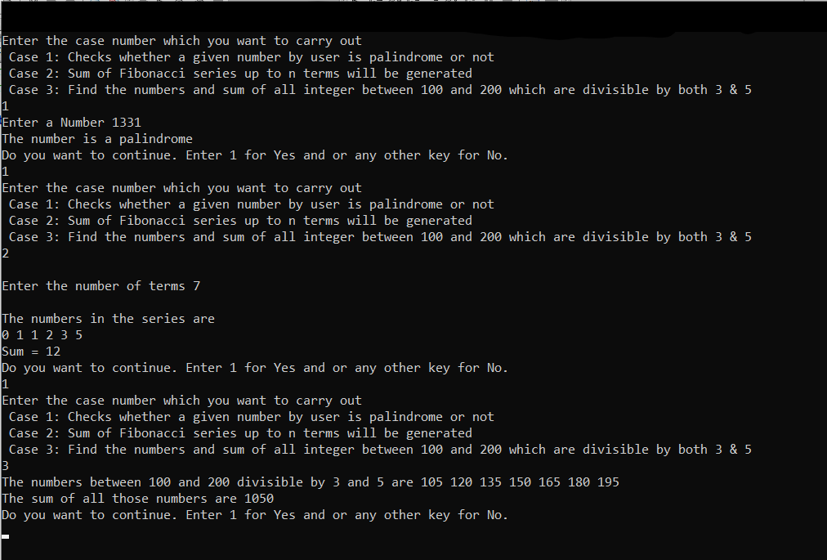

Conclusion:

In this experiment we have learned the program of palindrome, Fibonacci series and also program to find the numbers divisible by 3 and 5 and their sum between the range 100 an 200 an also we learnt how to write menu driven program using switch case for the above 3 programs, using FOR, WHILE, DO WHILE and SWITCH CASE,

Post Lab Descriptive Questions

Write menu driven code for the following:

The program allows a user to enter five numbers and then asks the user to select a choice from a menu. The menu should offer the following options –
1. Display the smallest number entered
2. Display the largest number entered
3. Display the sum of the five numbers entered
4. Display the average of the five numbers entered.
5. Exit

CODE:

#include <stdio.h>
int main()
{
int n, num1, num2, num3, num4, num5, sum;
printf("Input 5 numbers : ");
scanf("%d%d%d%d%d", &num1, &num2, &num3, &num4, &num5);
int repeat=1;
while(repeat==1){
printf("\nChoose any one from below");
printf("\nEnter 1 to find out smallest number\n");
printf("Enter 2 to find out largest number\n");
printf("Enter 3 to find out sum of the numbers\n");
printf("Enter 4 to find out average of the numbers\n");
printf("\nEnter choice no :");
scanf("%d", &n);
switch (n)
{
case 1:
{
if (num1 < num2 && num1 < num3 && num1 < num4 && num1 < num5)
{
printf("Smallest number is %d \n", num1);
}
else if (num2 < num1 && num2 < num3 && num2 < num4 && num2 < num5)
{
printf("Smallest number is %d \n", num2);
}
else if (num3 < num1 && num3 < num2 && num3 < num4 && num3 < num5)
{
printf("Smallest number is %d \n", num3);
}
else if (num4 < num1 && num4 < num2 && num4 < num3 && num4 < num5)
{
printf("Smallest number is %d \n", num4);
}
else if (num5 < num1 && num5 < num2 && num5 < num3 && num5 < num4)
{
printf("Smallest number is %d \n", num5);
}
break;
}
case 2:
{
if (num1 > num2 && num1 > num3 && num1 > num4 && num1 > num5)
{
printf("Greatest number is %d \n", num1);
}
else if (num2 > num1 && num2 > num3 && num2 > num4 && num2 > num5)
{
printf("Greatest number is %d \n", num2);
}
else if (num3 > num1 && num3 > num2 && num3 > num4 && num3 > num5)
{
printf("Greatest number is %d \n", num3);
}
else if (num4 > num1 && num4 > num2 && num4 > num3 && num4 > num5)
{
printf("Greatest number is %d \n", num4);
}
else if (num5 > num1 && num5 > num2 && num5 > num3 && num5 > num4)
{
printf("Greatest number is %d \n", num5);
}
break;
}
case 3:{
sum = num1 + num2 + num3 + num4 + num5;
printf("The sum of the 5 numbers you entered is %d \n", sum);
break;
}
case 4:
{
float average = (num1 + num2 + num3 + num4 + num5) / 5;
printf("The average of the 5 numbers you entered is %f \n", average);
break;
}
default: printf("wrong choice");
}
int again;
printf("\n\nDo you want to run again? \nEnter 1 for yes and 0 for no: ");
scanf("%d",&again);
if(again==0){
repeat = 0;
}
}
}

OUTPUT:

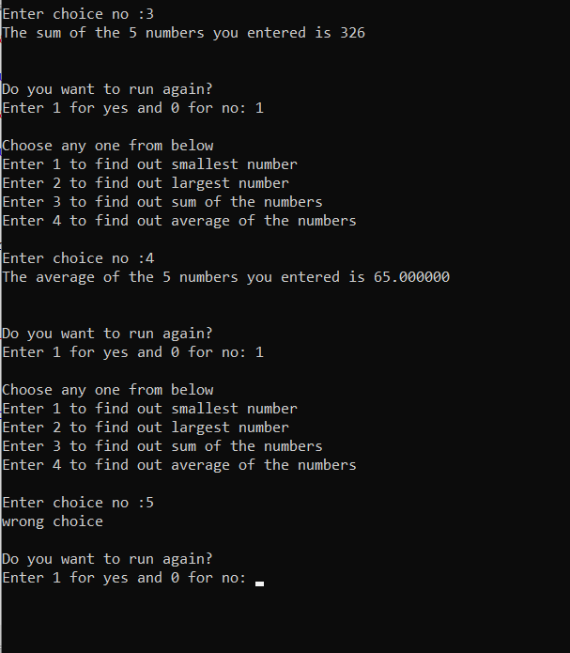

Date: _____________ Signature of faculty in-charge

